CS 255 Project One: Business Requirements Document
Caleb Dinsmore | Southern New Hampshire University

System Components and Design

Purpose
- Design a cloud-based DriverPass system that helps customers prepare for Department of Motor Vehicles (DMV) driving tests through online classes, practice exams, and scheduled on-the-road instruction.
- Give DriverPass customers, employees, management, and information technology (IT) staff role-appropriate access to accurate training, reservation, account, and reporting information.
- Replace disconnected manual work with one system that can coordinate customers, drivers, vehicles, two-hour lessons, training packages, payments, progress, and staff activity.

System Background
- DriverPass is responding to a market problem in which more than 65% of applicants fail the driving license examination after relying mainly on previous tests instead of receiving complete preparation.
- The proposed system will combine online learning and practice tests with in-person instruction and behind-the-wheel training.
- Core components include customer and employee accounts, role-based access, student registration, three selectable training packages, reservations, driver and vehicle scheduling, online course content, practice exams, progress tracking, driver notes, payments, notifications, audit reporting, and downloadable data.
- The system will connect with DMV information so DriverPass can receive notices about changes to rules, policies, and sample questions and keep its training material current.
- Because DriverPass does not want to manage local backups or security infrastructure, the solution will run as a cloud-hosted web application.

Objectives and Goals
- Allow a customer or secretary to create and maintain a complete student record, including contact information and pickup/drop-off location.
- Allow customers to select a training package and schedule, modify, or cancel available two-hour driving sessions online; allow the secretary to perform the same actions by phone or in person.
- Prevent scheduling conflicts by matching each reservation to one available customer, driver, vehicle, date, and time.
- Provide online classes and practice tests, and show each test's name, time taken, score, and status: not taken, in progress, failed, or passed.
- Store driver lesson times and comments so authorized users can review student progress.
- Use role-based permissions for the owner, IT officer, secretary, drivers, and customers, while recording who creates, changes, or cancels reservations.
- Notify authorized staff when the DMV publishes relevant updates and support timely updates to practice materials.
- Provide activity and operational reports that can be viewed, printed, and exported for use in tools such as Microsoft Excel.

Requirements

Nonfunctional Requirements

Performance Requirements
- The system shall operate as a responsive web application hosted in the cloud and remain usable from current desktop, laptop, tablet, and mobile browsers.
- Normal page loads, logins, searches, and reservation actions should complete within approximately three seconds under expected business load; longer report exports should show clear progress and complete without losing data.
- Reservation availability must update immediately after a successful booking, change, or cancellation to avoid double-booking a driver or vehicle.
- The hosting provider shall perform automated backups and support recovery from a recent backup after a failure.
- DMV update checks should occur automatically at least daily, with authorized staff notified when new information is available.
- The service should target 99.5% monthly availability, excluding scheduled maintenance that is announced in advance.

Platform Constraints
- The client-facing and employee-facing system shall be web-based and cloud-hosted rather than dependent on a locally installed application.
- The interface shall support current versions of major browsers on Windows, macOS, Android, and iOS.
- A centralized relational database is required to store customers, users, roles, packages, tests, reservations, vehicles, drivers, payments, notes, and audit records.
- Users may view and export authorized information from any supported device, but records may only be created or changed while connected to the system so separate offline copies do not create duplicate or conflicting data.
- Exports shall use a common format such as CSV or XLSX so Liam can work with approved report data in Microsoft Excel.

Accuracy and Precision
- Every person shall have a unique account identifier; permissions shall be determined by assigned role rather than by name.
- Usernames may be treated as case-insensitive, while passwords shall be case-sensitive. Leading and trailing spaces shall be removed from ordinary text input when appropriate.
- Required registration and payment fields shall be validated before submission, including formats for phone numbers, state, card expiration date, and security code.
- The scheduling logic shall use exact date-and-time values in consistent time-zone handling and reserve two-hour blocks only when the selected driver and vehicle are both available.
- The system shall calculate test scores consistently and assign only the defined statuses: not taken, in progress, failed, or passed.
- The IT officer shall receive alerts for repeated processing failures, integration failures, backup failures, suspicious login activity, or data conditions that could affect scheduling accuracy.

Adaptability
- Authorized administrators shall be able to add, disable, reactivate, and modify user accounts and role assignments without changing source code.
- The owner or another authorized manager shall be able to disable an existing package so no new customers can select it.
- Package details, test questions, DMV content, driver/vehicle availability, and contact information shall be stored as configurable data whenever practical so routine changes do not require code changes.
- Adding or removing entire system modules and creating fundamentally new package structures are outside the first release and may require a developer or systems analyst.
- The application shall use supported web standards and isolated service/integration layers so browser, cloud-platform, and DMV interface changes can be addressed with limited impact on the rest of the system.
- The IT officer shall have administrative access to account maintenance, audit logs, configuration, monitoring, and troubleshooting functions, but payment data access shall still follow least-privilege rules.

Security
- All users shall log in with a unique username and password, and the system shall enforce role-based authorization for each page and action.
- All data exchanged between browsers and the cloud service shall be encrypted with HTTPS/TLS; sensitive stored data shall be encrypted and protected by least-privilege access.
- Passwords shall be stored using a strong salted one-way password hash and shall never be displayed to staff.
- After several failed login attempts, the system shall apply progressive delay or temporary account lockout and record the event for IT review.
- Customers shall be able to request a time-limited password-reset link sent to a verified contact method; the IT officer shall be able to initiate staff account resets and disable terminated employees promptly.
- Payment processing should use a compliant third-party payment service and tokenization so DriverPass does not retain full card numbers or security codes after authorization.
- The system shall record security-relevant actions and reservation changes in tamper-resistant audit logs that identify the user, action, date/time, and affected record.
- User sessions shall expire after inactivity, and users shall be able to sign out from any device.

Functional Requirements
- The system shall validate user credentials and provide access based on the user's assigned role.
- The system shall allow the IT officer to create, modify, reset, disable, and reactivate employee and customer accounts.
- The system shall allow a customer or secretary to register a student and maintain the student's name, address, phone number, state, pickup location, and matching drop-off location.
- The system shall present Package One, Package Two, and Package Three with their included training hours, lessons, online content, and practice-test access.
- The system shall allow authorized management users to disable a package so it cannot be selected by new customers.
- The system shall allow a customer or secretary to schedule, modify, and cancel two-hour driving lessons.
- The system shall verify availability and assign each driving reservation to one student, one driver, one vehicle, one date, and one two-hour time block.
- The system shall prevent conflicting reservations for the same driver, vehicle, or customer.
- The system shall allow authorized users to record payment through a secure payment processor during registration or package purchase.
- The system shall provide Package Three customers access to online course materials and practice exams.
- The system shall record each practice test's name, elapsed time, score, and status as not taken, in progress, failed, or passed.
- The system shall allow a driver to record lesson start/end times and comments and allow authorized staff and the student to view appropriate notes.
- The system shall provide a contact page and allow authorized staff to contact a student using stored contact information.
- The system shall receive or check for DMV updates and notify authorized staff when rules, policies, or sample questions change.
- The system shall create an audit trail showing who created, modified, or canceled a reservation and when the action occurred.
- The system shall generate printable activity reports and export authorized report data in a format compatible with Microsoft Excel.
- The system shall allow users to view previously downloaded reports offline while preventing offline modification of live system records.

User Interface
- The interface shall use responsive web pages that adjust to desktop and mobile screens and provide consistent navigation, readable labels, clear feedback, and accessible keyboard operation.
- Customers shall be able to register, manage contact and pickup information, choose a package, schedule/modify/cancel lessons, reset a forgotten password, access eligible course content, take practice tests, review test progress, and contact DriverPass.
- The secretary shall be able to create or update customer records, select packages, take payment, and schedule/modify/cancel appointments for customers who call or visit the office.
- Drivers shall be able to view their assigned lessons and vehicles and enter lesson start/end times and driver comments.
- The owner shall be able to review operational information, disable packages, view/print activity reports, and export authorized information.
- The IT officer shall have an administration area for accounts, roles, password resets, access blocking, audit review, configuration, integration status, and technical monitoring.
- The student progress page shall display test name, time taken, score, and status, while the driver-notes area shall display lesson time, start time, end time, and comments.
- Forms shall identify required fields, validate entries near the affected field, confirm successful actions, and ask for confirmation before destructive actions such as canceling a lesson.

Assumptions
- Customers and employees have an internet connection and access to a supported browser when they need to create or change live data.
- DriverPass will maintain accurate driver schedules, vehicle availability, package information, and authorized employee roles.
- Each vehicle is normally associated with a driver, but the data model will keep driver and vehicle assignments separate so authorized staff can handle absences or maintenance.
- Pickup and drop-off locations are the same in the initial release, as stated in the interview.
- The DMV provides a usable update source, such as an API, feed, or authorized file/email process; the exact technical connection will be confirmed during design.
- A third-party cloud provider and payment processor can meet availability, backup, encryption, and payment-security needs.
- Practice-test passing thresholds and package pricing will be supplied and approved by DriverPass before configuration and testing.

Limitations
- The first release will not allow nontechnical staff to add or remove complete system modules; those changes require future development.
- Users cannot modify live data offline because offline editing could create conflicting or duplicate records.
- The system depends on internet service, cloud-host availability, the payment provider, and the availability and format of DMV updates.
- The current design supports the stated three packages and the ability to disable them; advanced package customization is deferred unless separately approved.
- The project schedule assumes the customer approves the design on March 10–11 without requesting major revisions. Significant changes would affect later dates.
- The schedule, staffing, and budget described in the interview limit the first release to the agreed core functions; optional future features will require separate prioritization.

Gantt Chart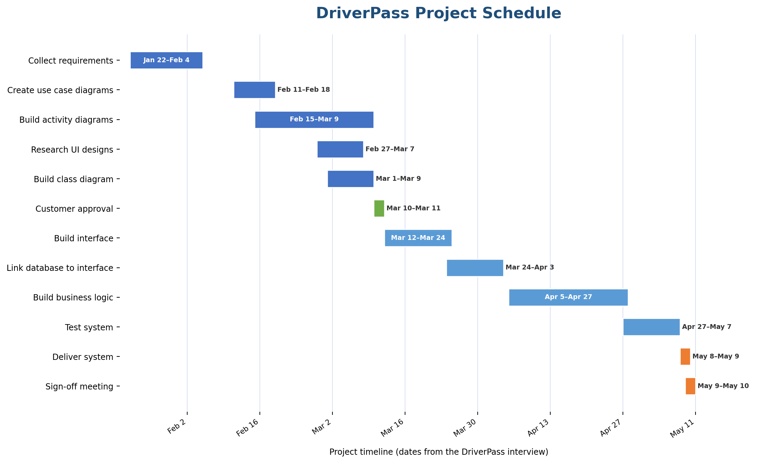
Figure 1. DriverPass project schedule based on the dates and dependencies in the interview transcript.

